Skin Support in IGDT

Introduction

This document explains the design and configuration details of skinning feature in IGDT. Skinning in IGDT can be achieved by changing property values of elements at run time. Currently this feature is available for OpenVG platform only. These settings are available in menu Project -> Project Settings under tab GUI Skinning. Users advised to configure these settings before starting the actual design.

Skinning in IGDT screens is achieved by below 2 features.
- Image theme support
- Layout theme support

Image theme support

Skinning through image theme can be achieved by changing the image file path at run time based on current Image theme. This feature requires all image files to be selected from sub directories of given “Theme folder in PC”. User should select “Use FileSystem” option in CodeGenOptions1 tab to generate image contents for all configured image themes.

Step by step instruction to configure and make use of image theme support.

- Configure a layer with platform type “OpenVG”

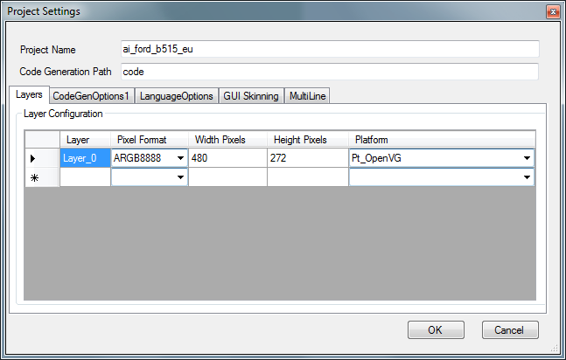

- Configure Theme folder in target with the path where the generated files will be available in target.
- Click the browse button and select the theme directory in development PC where the image files (*.PNG etc.) are available.
(This path can be either absolute or relative path to current directory)

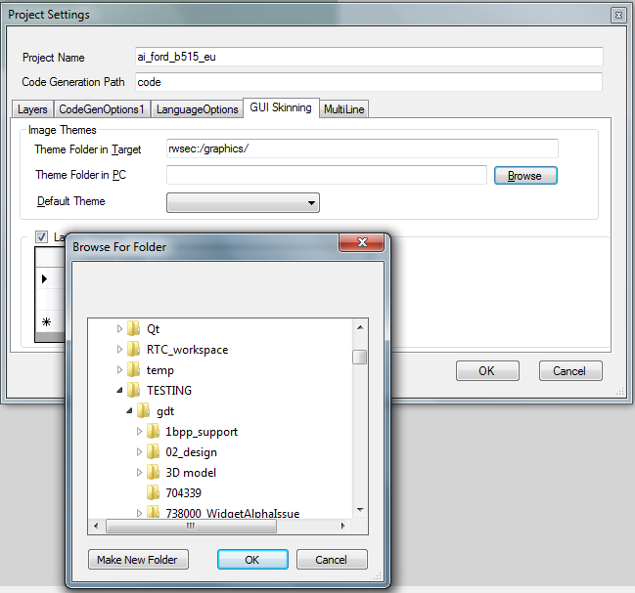

- Once the directory is selected, the combo box next to Default theme will be updated with a list of sub directories available in given path.
(In our example, the target folder is .\gdt.qt.resources\Resources\Theme_Support\ with two sub directories day and night as shown below)
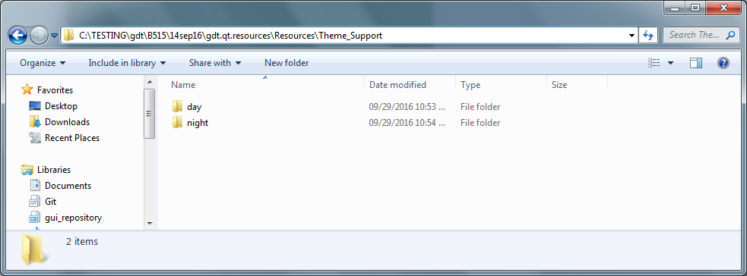

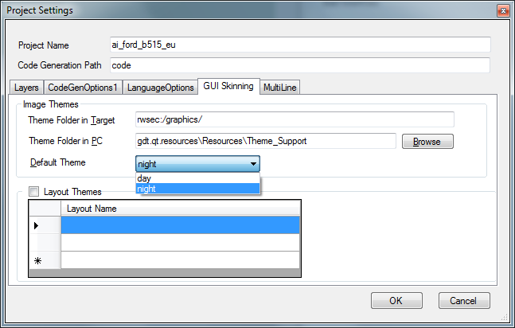

- Select the required directory from the available list as default theme.
(In our example, night is selected)

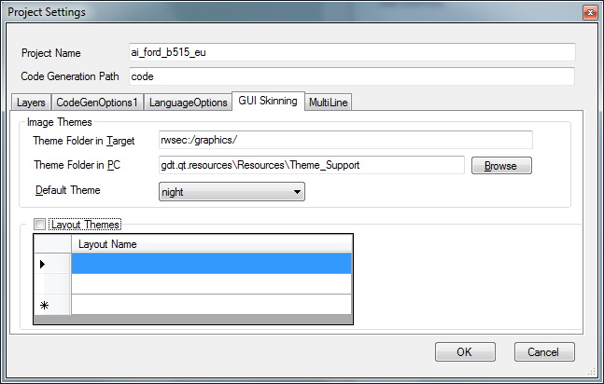

Now the Image theme settings are configured and IGDT is ready to handle and generate code as per given configuration.

While designing the screens, all image files should be selected from any one of sub directory of default theme folder.
(In our example, the user set night directory as default theme. So all the images should be selected from directory .\gdt.qt.resources\Resources\Theme_Support\night\* and the user shall ensure the image file in development PC is available in other themes as well with same file path.

Say for an image element “img_statusbar_background” is configured with image path gdt.qt.resources\Resources\Theme_Support\ night\Background\statusbar_background.png,
user needs to ensure the same/another image should be available under gdt.qt.resources\Resources\Theme_Support\day\ Background\ statusbar_background.png.

statusbar_background.png in different theme directories could be same or different file based on user’s design requirement.

IGDT will generate code (*.bin) in target folder as

.\code\gresfiles\day\background\img_statusbar_background_ovg.bin
.\code\gresfiles\night\background\img_statusbar_background_ovg.bin

Note: If a configured image data file is not available in current theme directory at run time, Graphics Manager 02 will load and render the image data file from default image theme directory)

GDT Viewer updates the screen based on the theme selected.
For example, if the default theme set to day directory and the image path is
gdt.qt.resources\Resources\Theme_Support\night\Background\statusbar_background.png, then the image will be taken from same path.
If the user changed the default theme to day directory, the image path will be calculated and rendered from
gdt.qt.resources\Resources\Theme_Support\day\Background\statusbar_background.png

Since the image path is calculated at run time, user need not to configure different paths for an image file. But they need to ensure the image file is available in other theme directories as well.

Example screen when user selected day theme:

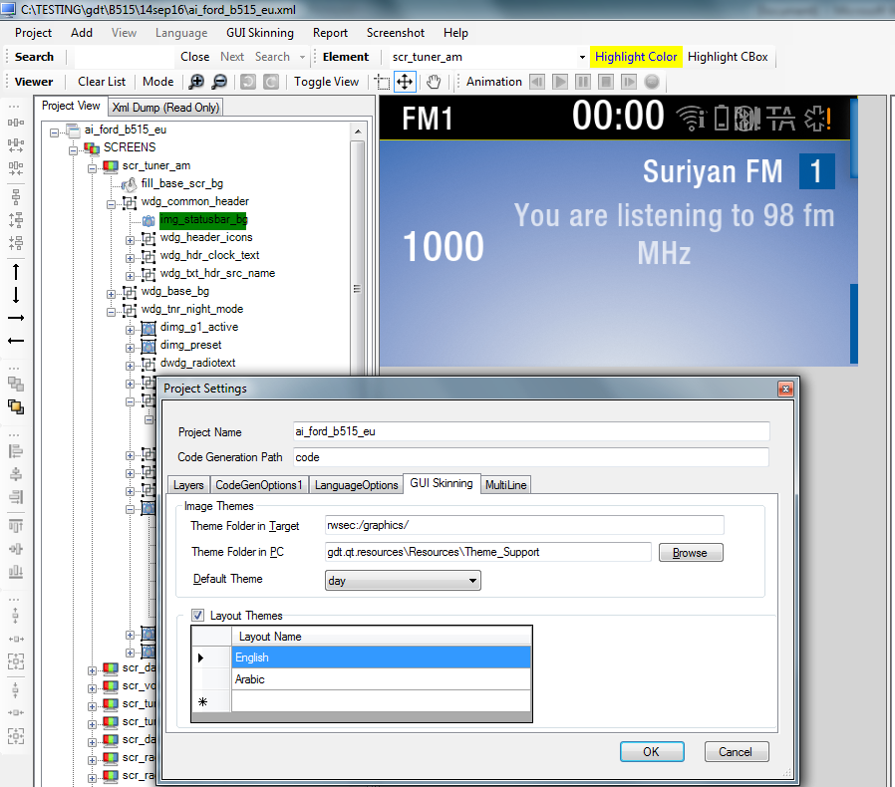

Example screen when user selected night theme:

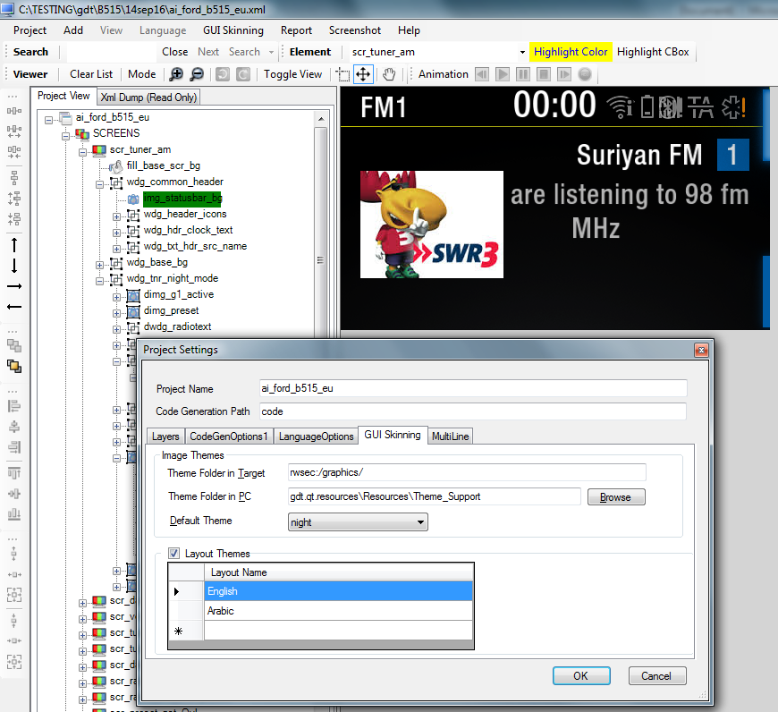

Note: After changing the image theme, user need to click on element/screen again to refresh the screen with current image theme configuration.

Design file (*.xml) changes for Image theme feature:

None of the image properties in XML are updated for this image theme feature.

Layout Themes support

Layout settings can be accessed through menu Project -> Project Settings under tab GUI Skinning.

Currently this feature is limited to OpenVG platform only.

Step by step instruction to configure Layout theme support.

- Tick “Layout Themes”
- Enter the layout names in the list box. (First layout name will be marked as selected layout first time)
In our example, we configured 2 layouts English and Arabic.

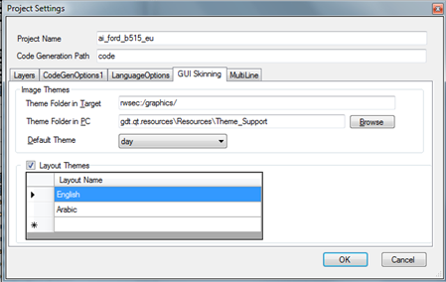

- Click OK.
- Check the menu bar item “GUI Skining”.
- Select the menu GUI Skinning -> Layout and click on the required Layout name.

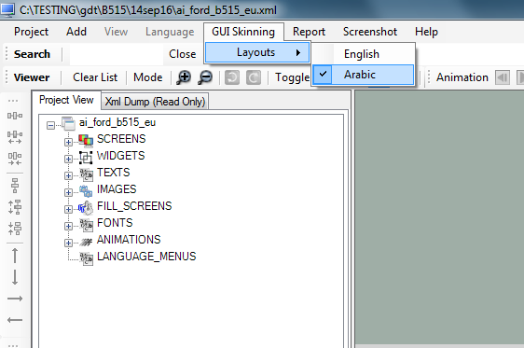

- User need to configure the below listed properties of elements N number of times, where N is the number of layouts configured.
- Configured settings will be saved under current layout selected.

IGDT element’s properties affected for layout are listed below.

Element | Property in Viewer | XML Property
Image | XYLocation.X | KEYWORD_X
 | XYLocation.Y | KEYWORD_Y
 | ImageFile | KEYWORD_IMAGE_FILE
Fill Screen | FillRectangle.X | KEYWORD_X
 | FillRectangle.Y | KEYWORD_Y
Text | DrawPoint.X | KEYWORD_X
 | DrawPoint.Y | KEYWORD_Y
 | Clipping Mode | KEYWORD_TEXT_CLIP_MODE
 | Alignment | KEYWORD_ALIGNMENT
MAP(Motion Along Path) | Path | path_data
MAL(Motion Along Line) | Point | ex, ey
Widget** | Clip Area.X**  Clip Area.Y**  Clip Area.W**  Clip Area.H** | (Rectangle)  KEYWORD_X  KEYWORD_Y  KEYWORD_W  KEYWORD_H
** Feature under evaluation.

These properties are saved in XML as per the number of layouts configured.

Examples:
Image: element name: img_overlayOneLine_bg

Property | Values in Layout 0 | Values in Layout 2
XYLocation | 10,15 | 20,25
Image file | gdt.qt.resources\Resources\Theme_Support\night\Background\overlayOneLine.png | gdt.qt.resources\Resources\Theme_Support\night\Background2\overlayOneLine2.png

XML:
<img_overlayOneLine_bg KEYWORD_X="0" KEYWORD_Y="0" KEYWORD_ALPHA="255" KEYWORD_DRAW_COLOR="4294967295" KEYWORD_USE_BGCOLOR="4278190080" KEYWORD_MACROTEXT=" " matrix="1.00000,0.00000,0.00000,0.00000,1.00000,0.00000,0.00000,0.00000,1.00000" pivotx="0.00000" pivoty="0.00000" refl-dist="0.00000" refl-height="0.00000">
<layout_properties>
<layout_0 KEYWORD_X="10" KEYWORD_Y="15" />
<layout_1 KEYWORD_X="20" KEYWORD_Y="25" />
</layout_properties>
</img_overlayOneLine_bg>

<IMAGES>
<img_overlayOneLine_bg KEYWORD_IMAGE_FILE="gdt.qt.resources\Resources\Theme_Support\night\Background\overlayOneLine.png" KEYWORD_TYPE="ARGB8888" KEYWORD_DRAW_MODE="Static" KEYWORD_RLE_COMPRESSION="HwRLE" KEYWORD_X="0" KEYWORD_Y="0" KEYWORD_COPY_X="0" KEYWORD_COPY_Y="0" KEYWORD_COPY_W="0" KEYWORD_COPY_H="0" opq_x="0" opq_y="0" opq_w="0" opq_h="0" KEYWORD_DYNAMIC_XY="False" KEYWORD_ALPHA="255" KEYWORD_DYNAMIC_ALPHA="False" KEYWORD_DRAW_COLOR="4294967295" KEYWORD_TRANS_COLOR="4278190080" KEYWORD_SELECTED_INDEX="0" KEYWORD_IMAGE_LUT_FILE="" KEYWORD_COLOR_TRANSPARENCY="False" KEYWORD_USE_BGCOLOR="4278190080" KEYWORD_W="480" KEYWORD_H="71" matrix="1.00000,0.00000,0.00000,0.00000,1.00000,0.00000,0.00000,0.00000,1.00000" pivotx="0.00000" pivoty="0.00000" refl-dist="0.00000" refl-height="0.00000">
<img_overlayOneLine_bgELEMENTS />
<layout_properties>
<layout_0 KEYWORD_IMAGE_FILE="gdt.qt.resources\Resources\Theme_Support\night\Background\overlayOneLine.png" KEYWORD_X="0" KEYWORD_Y="0" />
<layout_1 KEYWORD_IMAGE_FILE="gdt.qt.resources\Resources\Theme_Support\night\Background2\overlayOneLine2.png" KEYWORD_X="0" KEYWORD_Y="0" />
</layout_properties>
</img_overlayOneLine_bg>
</IMAGES>

Generated files:

File: hmi_gfx_mgr02_config.dat

Layout 1(English) | Layout 2(Arabic)
GFX_MGR02_IMAGE_DEF_T const lc_english_image_layer_def_S[GFX_MGR02_NUM_OF_IMAGE_LAYERS] =  {  /* GFX_IMG_OVERLAYONELINE_BG_OVG_BASEID */  ,{  /* GFX_IMG_OVERLAYONELINE_BG_OVG */  /* format */ VG_sARGB_8888,  /* compression */ GFX_MGR02_IMAGE_COMPRESSION_HWRLE,  /* chroma_key */ GFX_MGR02_IMAGE_CHROMA_KEY_NONE,  /* vaoa index */ 0,  /* CLUT index */ GFX_MGR02_NUM_OF_CLUTS,  #if defined(GFX_MGR02_COMPRESSION_ENABLED)  /* rle size */ 4241,  #endif  /* width */ 480,  /* height */ 71,  /* trans color */ 0xFF000000,  /* Path */ (char const *)"/background/img_overlayoneline_bg_ovg.bin", /* Image File=overlayOneLine.png, CopyX=0, CopyY=0 */  }  } | GFX_MGR02_IMAGE_DEF_T const lc_arabic_image_layer_def_S[GFX_MGR02_NUM_OF_IMAGE_LAYERS] =  {  /* GFX_IMG_OVERLAYONELINE_BG_OVG_BASEID */  ,{  /* GFX_IMG_OVERLAYONELINE_BG_OVG */  /* format */ VG_sARGB_8888,  /* compression */ GFX_MGR02_IMAGE_COMPRESSION_HWRLE,  /* chroma_key */ GFX_MGR02_IMAGE_CHROMA_KEY_NONE,  /* vaoa index */ 0,  /* CLUT index */ GFX_MGR02_NUM_OF_CLUTS,  #if defined(GFX_MGR02_COMPRESSION_ENABLED)  /* rle size */ 4241,  #endif  /* width */ 480,  /* height */ 71,  /* trans color */ 0xFF000000,  /* Path */ (char const *)"/background2/img_overlayoneline_bg_ovg.bin", /* Image File=overlayOneLine2.png, CopyX=0, CopyY=0 */  }  }
GFX_MGR02_IMAGE_PROPERTY const lc_english_img_const_property_S[GFX_MGR02_NUM_SIMAGE_INSTANCES] ={  {  /* GFX_IMG_OVERLAYONELINE_BG_1, LAYOUT_ID=0 */  /* alpha */ 255,  /* base_id */ 0,  /* coord */ {10,15},  /* fg_color */ 0xFFFFFFFF,  #if defined(GFX_MGR02_OPEN_VG) || defined(GFX_MGR02_OPEN_GL) || defined(GFX_MGR02_FUJITSU) || defined(GFX_MGR02_AMBER)  /* matrix */ {1.00000f,0.00000f,0.00000f,0.00000f,1.00000f,0.00000f,0.00000f,0.00000f,1.00000f},  /* pivot */ {0.00000f,0.00000f}  #endif  }  } | GFX_MGR02_IMAGE_PROPERTY const lc_arabic_img_const_property_S[GFX_MGR02_NUM_SIMAGE_INSTANCES] ={  {  /* GFX_IMG_OVERLAYONELINE_BG_1, LAYOUT_ID=1 */  /* alpha */ 255,  /* base_id */ 0,  /* coord */ {20,25},  /* fg_color */ 0xFFFFFFFF,  #if defined(GFX_MGR02_OPEN_VG) || defined(GFX_MGR02_OPEN_GL) || defined(GFX_MGR02_FUJITSU) || defined(GFX_MGR02_AMBER)  /* matrix */ {1.00000f,0.00000f,0.00000f,0.00000f,1.00000f,0.00000f,0.00000f,0.00000f,1.00000f},  /* pivot */ {0.00000f,0.00000f}  #endif  }  }

FillScreen: element name: fill_base_scr_bg

Property | Value in Layout 0 | Value in Layout 2
FillRectangle | 0,10, 480, 272 | 20,30, 480, 272

XML:
<fill_base_scr_bg KEYWORD_X="0" KEYWORD_Y="0" KEYWORD_DRAW_COLOR="4278190080" KEYWORD_W="480" KEYWORD_H="272" KEYWORD_ALPHA="255" KEYWORD_MACROTEXT=" " matrix="1.00000,0.00000,0.00000,0.00000,1.00000,0.00000,0.00000,0.00000,1.00000" pivotx="0.00000" pivoty="0.00000" refl-dist="0.00000" refl-height="0.00000">
<layout_properties>
<layout_0 KEYWORD_X="0" KEYWORD_Y="10" />
<layout_1 KEYWORD_X="20" KEYWORD_Y="30" />
</layout_properties>
</fill_base_scr_bg>

<FILL_SCREENS>
<fill_base_scr_bg KEYWORD_TYPE="Normal" KEYWORD_IMAGE_FILE="" KEYWORD_DRAW_COLOR="4278190080" KEYWORD_X="0" KEYWORD_Y="0" KEYWORD_W="480" KEYWORD_H="272" KEYWORD_DYNAMIC_XY="False" KEYWORD_DYNAMIC_COLOR="False" KEYWORD_ALPHA="255" KEYWORD_DYNAMIC_ALPHA="False" pivotx="0.00000" pivoty="0.00000" matrix="1.00000,0.00000,0.00000,0.00000,1.00000,0.00000,0.00000,0.00000,1.00000">
<layout_properties>
<layout_0 KEYWORD_X="0" KEYWORD_Y="10" />
<layout_1 KEYWORD_X="20" KEYWORD_Y="30" />
</layout_properties>
</fill_base_scr_bg>
</FILL_SCREENS>

Generated files:
File: hmi_gfx_mgr02_config.dat

Layout 0 (English) | Layout 1(Arabic)
GFX_MGR02_FILL_PROPERTY const lc_english_fill_const_property_S[GFX_MGR02_NUM_FILL_INSTANCES] =  {  {  /* GFX_FILL_BASE_SCR_BG_1, LAYOUT_ID=0 */  /* alpha */ 255,  /* base_id */ 0,  /* coord */ {0,10},  #if defined(GFX_MGR02_OPEN_VG) || defined(GFX_MGR02_OPEN_GL) || defined(GFX_MGR02_FUJITSU) || defined(GFX_MGR02_AMBER)  /* matrix */ {1.00000f,0.00000f,0.00000f,0.00000f,1.00000f,0.00000f,0.00000f,0.00000f,1.00000f},  /* pivot */ {0.00000f,0.00000f}  #endif  } | GFX_MGR02_FILL_PROPERTY const lc_arabic_fill_const_property_S[GFX_MGR02_NUM_FILL_INSTANCES] =  {  {  /* GFX_FILL_BASE_SCR_BG_1, LAYOUT_ID=1 */  /* alpha */ 255,  /* base_id */ 0,  /* coord */ {20,30},  #if defined(GFX_MGR02_OPEN_VG) || defined(GFX_MGR02_OPEN_GL) || defined(GFX_MGR02_FUJITSU) || defined(GFX_MGR02_AMBER)  /* matrix */ {1.00000f,0.00000f,0.00000f,0.00000f,1.00000f,0.00000f,0.00000f,0.00000f,1.00000f},  /* pivot */ {0.00000f,0.00000f}  #endif  }

Text: element name: txt_vol_t1

Property | Value in Layout 0 | Value in Layout 2
DrawPoint | 64,3 | 62,8
Clipping Mode | Text Fit | Normal
Alignment | Left | Right

XML:
<txt_vol_t1 KEYWORD_X="64" KEYWORD_Y="3" KEYWORD_HEIGHT="1" KEYWORD_DRAW_COLOR="4294967295" KEYWORD_USE_BGCOLOR="4278190080" KEYWORD_ALPHA="255" KEYWORD_MACROTEXT=" " matrix="1.00000,0.00000,0.00000,0.00000,1.00000,0.00000,0.00000,0.00000,1.00000" pivotx="0.00000" pivoty="0.00000" refl-dist="0.00000" refl-height="0.00000">
<layout_properties>
<layout_0 KEYWORD_X="64" KEYWORD_Y="3" />
<layout_1 KEYWORD_X="62" KEYWORD_Y="8" />
</layout_properties>
</txt_vol_t1>

<TEXTS>
<txt_vol_t1 KEYWORD_SAMPLE_TEXT="Volume" KEYWORD_SAMPLE_SELECT_STRING="'Volume'" KEYWORD_DRAW_COLOR="4294967295" KEYWORD_X="244" KEYWORD_Y="3" KEYWORD_W="165" KEYWORD_LENGTH="6" KEYWORD_DRAW_MODE="Transparent" KEYWORD_ALIGNMENT="Right" KEYWORD_FONT_ID="Helvetica_Neue_Text_Bold_33" KEYWORD_DYNAMIC_XY="True" KEYWORD_DYNAMIC_COLOR="True" KEYWORD_USE_BG_YES_NO="" KEYWORD_USE_BGIMAGE="" KEYWORD_USE_BGCOLOR="4278190080" KEYWORD_TEXT_CLIP_STRING="" KEYWORD_TEXT_CLIP_MODE="Text Fit" KEYWORD_TEXT_ORIENTATION="Horizontal" KEYWORD_TEXT_DIRECTION="Normal" KEYWORD_ALPHA="255" KEYWORD_DYNAMIC_ALPHA="True" KEYWORD_TYPE="False" KEYWORD_HEIGHT="1" KEYWORD_SCROLL_MODE="False" cache_mode="False" pivotx="0.00000" pivoty="0.00000" matrix="1.00000,0.00000,0.00000,0.00000,1.00000,0.00000,0.00000,0.00000,1.00000" glow_enabled="False" glow_radius="11" glow_sigma="3.50000" line_count="1" wrap_mode="None" line_spacing="0" scroll_mode="Pixel" max_line_length="1">
<layout_properties>
<layout_0 KEYWORD_ALIGNMENT="Left" KEYWORD_TEXT_CLIP_MODE="Text Fit" KEYWORD_X="64" KEYWORD_Y="3" />
<layout_1 KEYWORD_ALIGNMENT="Right" KEYWORD_TEXT_CLIP_MODE="Normal" KEYWORD_X="62" KEYWORD_Y="8" />
</layout_properties>
</txt_vol_t1>
</TEXTS>

Generated files:
File: hmi_gfx_mgr02_config.dat

Layout 0 (English) | Layout 1 (Arabic)
GFX_MGR02_TEXT_DEF_T const lc_english_text_layer_def_S[GFX_MGR02_NUM_OF_TEXT_LAYERS] = {  /* GFX_TXT_VOL_T1_BASEID */  ,{  /* Index to text */ 5964,  /* Width */ 165,  /* Num of characters */ 6,  /* Font ID */ GFX_MGR02_FONT_ID_HELVETICA_NEUE_TEXT_BOLD_33,  #if defined(GFX_MGR02_OPEN_VG) && (GFX_MGR02_NUM_OF_MULTI_LINE_TEXTS > 0)  /* Num of lines */ 1,  /* Inter elem space */ 0,  /* Max num of lines */ 1,  #endif  /* Justification */ GFX_MGR02_TP_ALIGN_LEFT,  /* Orientation */ GFX_MGR02_TO_HORIZONTAL,  /* draw_mode */ GFX_MGR02_TP_DRAW_TRANSP,  /* clip_mode */ GFX_MGR02_TP_CLIP_FIT,  #if defined(GFX_MGR02_OPEN_GL) && (GFX_MGR02_GLES_VERSION == GFX_MGR02_GLES_20) && (GFX_MGR02_EXT_FONT_ENGINE == GFX_MGR02_FREETYPE)  /* Glow_radius */ 0,  /* Glow_sigma */ 0.00000f,  /* Glow_effect */ 0,  #endif  #if defined(GFX_MGR02_OPEN_VG) && (GFX_MGR02_NUM_OF_MULTI_LINE_TEXTS > 0)  /* Scroll mode */ GFX_MGR02_SCROLL_PIXEL,  /* Wrap mode */ GFX_MGR02_WRAP_NONE,  #endif  /* Static/Dynamic */ 1,  /* Scroll */ GFX_MGR02_TP_SCROLL_DISABLE,  #if defined(GFX_MGR02_OPEN_GL) && (GFX_MGR02_GLES_VERSION == GFX_MGR02_GLES_20) && (GFX_MGR02_EXT_FONT_ENGINE == GFX_MGR02_FREETYPE)  /* text_cache */ GFX_MGR02_TEXT_CACHE_DISABLE  #endif  }  } | GFX_MGR02_TEXT_DEF_T const lc_arabic_text_layer_def_S[GFX_MGR02_NUM_OF_TEXT_LAYERS] ={  /* GFX_TXT_VOL_T1_BASEID */  ,{  /* Index to text */ 5964,  /* Width */ 165,  /* Num of characters */ 6,  /* Font ID */ GFX_MGR02_FONT_ID_HELVETICA_NEUE_TEXT_BOLD_33,  #if defined(GFX_MGR02_OPEN_VG) && (GFX_MGR02_NUM_OF_MULTI_LINE_TEXTS > 0)  /* Num of lines */ 1,  /* Inter elem space */ 0,  /* Max num of lines */ 1,  #endif  /* Justification */ GFX_MGR02_TP_ALIGN_RIGHT,  /* Orientation */ GFX_MGR02_TO_HORIZONTAL,  /* draw_mode */ GFX_MGR02_TP_DRAW_TRANSP,  /* clip_mode */ GFX_MGR02_TP_CLIP_NORMAL,  #if defined(GFX_MGR02_OPEN_GL) && (GFX_MGR02_GLES_VERSION == GFX_MGR02_GLES_20) && (GFX_MGR02_EXT_FONT_ENGINE == GFX_MGR02_FREETYPE)  /* Glow_radius */ 0,  /* Glow_sigma */ 0.00000f,  /* Glow_effect */ 0,  #endif  #if defined(GFX_MGR02_OPEN_VG) && (GFX_MGR02_NUM_OF_MULTI_LINE_TEXTS > 0)  /* Scroll mode */ GFX_MGR02_SCROLL_PIXEL,  /* Wrap mode */ GFX_MGR02_WRAP_NONE,  #endif  /* Static/Dynamic */ 1,  /* Scroll */ GFX_MGR02_TP_SCROLL_DISABLE,  #if defined(GFX_MGR02_OPEN_GL) && (GFX_MGR02_GLES_VERSION == GFX_MGR02_GLES_20) && (GFX_MGR02_EXT_FONT_ENGINE == GFX_MGR02_FREETYPE)  /* text_cache */ GFX_MGR02_TEXT_CACHE_DISABLE  #endif  }  }
GFX_MGR02_IMAGE_PROPERTY const lc_english_user_img_anim_property_S[GFX_MGR02_NUM_USER_ANIM_ELEMENTS] ={  /* GFX_TXT_VOL_T1_ANIM */  ,{  /* alpha */ 255,  /* base_id */ GFX_TXT_VOL_T1_BASEID,  /* coord */ { 64, 3},  /* draw color */ 0xFFFFFFFF,  /* bg color */ 0xFF000000,  #if defined(GFX_MGR02_OPEN_VG) || defined(GFX_MGR02_OPEN_GL) || defined(GFX_MGR02_FUJITSU) || defined(GFX_MGR02_AMBER)  /* matrix */ {1.00000f,0.00000f,0.00000f,0.00000f,1.00000f,0.00000f,0.00000f,0.00000f,1.00000f},  /* pivot */ {0.00000f,0.00000f}  #endif  }  } | GFX_MGR02_IMAGE_PROPERTY const lc_arabic_user_img_anim_property_S[GFX_MGR02_NUM_USER_ANIM_ELEMENTS] ={  /* GFX_TXT_VOL_T1_ANIM */  ,{  /* alpha */ 255,  /* base_id */ GFX_TXT_VOL_T1_BASEID,  /* coord */ { 62, 8},  /* draw color */ 0xFFFFFFFF,  /* bg color */ 0xFF000000,  #if defined(GFX_MGR02_OPEN_VG) || defined(GFX_MGR02_OPEN_GL) || defined(GFX_MGR02_FUJITSU) || defined(GFX_MGR02_AMBER)  /* matrix */ {1.00000f,0.00000f,0.00000f,0.00000f,1.00000f,0.00000f,0.00000f,0.00000f,1.00000f},  /* pivot */ {0.00000f,0.00000f}  #endif  }  }

MAP: element name: New_map_1

Property | Value in Layout 0 | Value in Layout 2
Path | gdt.qt.resources\Resources\Theme_Support\night\images\map\path1.svg | gdt.qt.resources\Resources\Theme_Support\night\images\map\path2.svg

XML:
<New_map_1 type="map" opt="" start_time="0" duration_msec="0" rate="0" interpolation="linear" interpol_handler="" data_type="static" config_handler="" path_data="">
<layout_properties>
<layout_0 path_data="gdt.qt.resources\Resources\Theme_Support\night\images\map\path1.svg" />
<layout_1 path_data="gdt.qt.resources\Resources\Theme_Support\night\images\map\path2.svg" />
</layout_properties>
<New_map_1ELEMENTS />
</New_map_1>

MAL: element name: win_dn_no_focus_frame_multi4ln_f1_mal

Property | Value in Layout 0 | Value in Layout 2
Point | 0,40 | 0,50

XML:
<win_dn_no_focus_frame_multi4ln_f1_mal type="mal" ex="0" ey="0" opt="" start_time="0" duration_msec="300" rate="30" interpolation="linear" interpol_handler="" data_type="static" config_handler="">
<layout_properties>
<layout_0 ex="0" ey="40" />
<layout_1 ex="0" ey="50" />
</layout_properties>
<win_dn_no_focus_frame_multi4ln_f1_malELEMENTS>
<wdg_no_focus_frame_multi4ln_pg />
</win_dn_no_focus_frame_multi4ln_f1_malELEMENTS>
</win_dn_no_focus_frame_multi4ln_f1_mal>

Generated code:
File name: hmi_gfx_anim_engine_data.rom

/* GFX_WIN_DN_NO_FOCUS_FRAME_MULTI4LN_F1_MAL*/
static GFX_ANIM_MAL_T const lc_win_dn_no_focus_frame_multi4ln_f1_mal_table_S[] =
{
{
0 , /* MAL end x */
40 /* MAL end y */
},
{
0 , /* MAL end x */
50 /* MAL end y */
}
};

Widget: element name: New_widgets_1

Property | Value in Layout 0 | Value in Layout 2
ClipArea | 10,11,12,13 | 30,31,32,33

XML:
<WIDGETS>
<New_widgets_1 KEYWORD_X="0" KEYWORD_Y="0" KEYWORD_W="0" KEYWORD_H="0" KEYWORD_TOUCH_ENABLE="No" KEYWORD_TYPE="Static" KEYWORD_DYNAMIC_XY="False" clip_enabled="True" KEYWORD_ALPHA="255" KEYWORD_USE_BGCOLOR="4278190080" KEYWORD_ALIGNMENT="None" KEYWORD_INTER_ELEM_SPACE="0" matrix="1.00000,0.00000,0.00000,0.00000,1.00000,0.00000,0.00000,0.00000,1.00000" pivotx="0.00000" pivoty="0.00000" KEYWORD_SELECTED_INDEX="0" rendering_engine="Rt_Default" rendering_mode="Merge Layers" KEYWORD_DISPLAY_PIX_DEPTH="RGB565" KEYWORD_TRANS_COLOR="4278190080" KEYWORD_COLOR_TRANSPARENCY="False" WDG_WARPID="255">
<New_widgets_1ELEMENTS>
</New_widgets_1ELEMENTS>
<layout_properties>
<layout_0 KEYWORD_X="10" KEYWORD_Y="11" KEYWORD_W="12" KEYWORD_H="13" />
<layout_1 KEYWORD_X="30" KEYWORD_Y="31" KEYWORD_W="32" KEYWORD_H="33" />
</layout_properties>
</New_widgets_1>
</WIDGETS>

Generated files:
File name: hmi_gfx_mgr02_config.dat
Layout 0 (English) | Layout 1 (Arabic)
GFX_MGR02_WIDGET_DEF_T const lc_english_swidget_layer_def_S[GFX_MGR02_NUM_OF_SWDGS] =  {  /* GFX_NEW_WIDGETS_1_BASEID */  {  /* New_widgets_1, layout_id=0 */  /* clip_mode */ GFX_MGR02_WP_CLIP_STATIC,  /* alignment */ GFX_MGR02_WP_ALIGN_NONE,  /* merge */ 1,  #if defined(GFX_MGR02_MULTI_COLOR_WDG_PRESENT)  /* multicolor */ 0,  #endif  /* inter_element_space */ 0,  /* clip_index */ 1,  #if defined(GFX_MGR02_KEPLER) || defined(GFX_MGR02_AMBER)  /* ImgId */ GFX_INVALID_WDG_IMAGE_BASEID ,  /* ClientId */ GFX_MGR02_INVALID_CLIENT_ID ,  /* render_engine */ GFX_MGR02_RT_DEFAULT,  /* frame_buffer_format */ GFX_MGR02_PIX_FORMAT_RGB565,  /* Background fillcolor*/ 0x00000000,  #endif  }  }; | GFX_MGR02_WIDGET_DEF_T const lc_arabic_swidget_layer_def_S[GFX_MGR02_NUM_OF_SWDGS] =  {  /* GFX_NEW_WIDGETS_1_BASEID */  {  /* New_widgets_1, layout_id=1 */  /* clip_mode */ GFX_MGR02_WP_CLIP_STATIC,  /* alignment */ GFX_MGR02_WP_ALIGN_NONE,  /* merge */ 1,  #if defined(GFX_MGR02_MULTI_COLOR_WDG_PRESENT)  /* multicolor */ 0,  #endif  /* inter_element_space */ 0,  /* clip_index */ 1,  #if defined(GFX_MGR02_KEPLER) || defined(GFX_MGR02_AMBER)  /* ImgId */ GFX_INVALID_WDG_IMAGE_BASEID ,  /* ClientId */ GFX_MGR02_INVALID_CLIENT_ID ,  /* render_engine */ GFX_MGR02_RT_DEFAULT,  /* frame_buffer_format */ GFX_MGR02_PIX_FORMAT_RGB565,  /* Background fillcolor*/ 0x00000000,  #endif  }  };
GFX_MGR02_VISIBLE_AREA const lc_english_elem_area_offset_SA[2] =  {  { 0, 0, 0, 0} /* 0*/  ,{ 10, 11, 12, 23} /* 1*/  }; | GFX_MGR02_VISIBLE_AREA const lc_arabic_elem_area_offset_SA[2] =  {  { 0, 0, 0, 0} /* 0*/  ,{ 30, 31, 32, 33} /* 1*/  };

